LAMPIRAN

PERATURAN DAERAH NOMOR 15 TAHUN 2017

TENTANG

PENGELOLAAN BARANG MILIK DAERAH

1. STRUKTUR PEJABAT PENGELOLA BARANG MILIK DAERAH

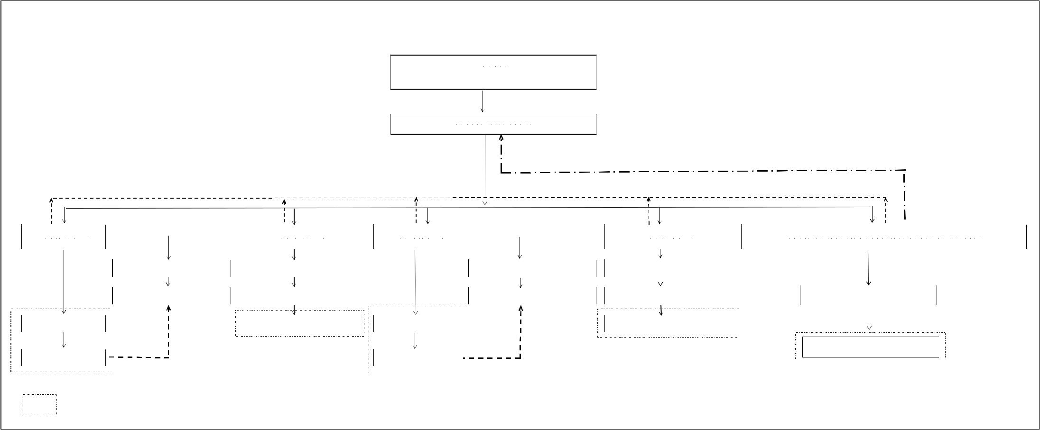

**STRUKTUR PEJABAT PENGELOLA BARANG MILIK DAERAH**

**Bupati**

**PemegangKekuasaanPengelolaan**

**BarangMilik Daerah**

**Sekretaris Daerah**

**PengelolaBarang**

`

|  |  |  |  |  |  |  |  |  |  |  |  |  |  |  |  |  |  |  |  |  |  |  |
| --- | --- | --- | --- | --- | --- | --- | --- | --- | --- | --- | --- | --- | --- | --- | --- | --- | --- | --- | --- | --- | --- | --- |
| **Kepala OPD** |  |  |  |  |  | **Kepala OPD** |  | **Kepala OPD** |  |  |  |  |  |  | **KepalaOPD** |  | **KepalaPejabatPengelolaKeuangan Daerah** | | | | |  |
|  |  |  |  |  |  |  |  |  |  |  |  |  |  |
| **PenggunaBarang** |  |  |  |  |  | **PenggunaBarang** |  | **PenggunaBarang** |  |  |  |  |  |  | **PenggunaBarang** |  |  |  | **PejabatPenatausahaanBarang** | | |  |
|  |  |  |  |  |  |  |  |  |  |  |  |  |  |  |  |  |  |  |  |  |  |  |
|  |  | **PejabatPenatausahaan** | |  |  | **PejabatPenatausahaan** |  |  |  |  | **PejabatPenatausahaanPengguna** | |  |  | **PejabatPenatausahaanPengguna** |  |  |  |  |  |  |  |
|  |  | **PenggunaBarang** | |  |  | **PenggunaBarang** |  |  |  |  | **Barang** | |  |  | **Barang** |  |  |  |  |  |  |  |
|  |  |  |  | | |  |  |  |  |  |  |  | | |  |  |  |  |  |  |  |  |
|  |  |  |  |  |  |  |  |  |  |  |  |  |  |  |  |  |  |  | **PengurusBarangPengelola** |  |  |  |
|  |  | **PengurusBarangPengguna** | |  | | **PengurusBarangPengguna** |  |  |  |  | **PengurusBarangPengguna** | |  | | **PengurusBarangPengguna** |  |  |  |  |  |  |
|  |  | |  | | |  |  |  |  | | |  | | |  |  |  |  |  |  |  |  |
| **KuasaPengguna** |  | |  | | | **PembantuPengurusBarang** |  | **KuasaPengguna** |  | | |  | | | **PembantuPengurusBarang** |  |  |  |  |  |  |  |
| **Barang** |  |  |  |  |  |  | **Barang** |  |  |  |  |  |  |  |  |  |  |  |  |  |
|  | |  | | |  |  |  | | |  | | |  |  |  |  |  |  |  |  |
|  |  |  |  |  |  |  |  |  |  |  |  |  |  |  |  |  |  |  |  | | |  |
|  |  |  |  |  |  |  |  |  |  |  |  |  |  |  |  |  |  |  | **PembantuPengurusBarang** | |  |  |
| **PengurusBarang** |  | |  | | |  |  | **PengurusBarang** |  | | |  | | |  |  |  |  |  |  |  |  |
| **Pembantu** |  |  |  |  |  |  |  | **Pembantu** |  |  |  |  |  |  |  |  |  |  |  |  |  |  |

Ket :